Background
Ordered Chaos has a range of advanced Word skills and can create just about anything into a template. Having worked with graphic designers in the past, we are capable of putting the interpretations into a functioning custom template for everyday use. Templates can include layouts, fields, styles, tables, autotext, macros, custom toolbars and much more. All designed to make using templates a simple process for your employees and limiting the administrative time before sending out your finished document.

Word Templates
Specialising in Microsoft Word templates we can convert your graphic designer’s layout into a functional and working template, or we can convert your existing letterhead into a digital format template.
Common template setup includes:
- Company Letter
- Report
- Invoice
- Work Health and Safety documents
Also the creation of the Microsoft Word, default blank, template in your own company format.

Default Blank Document
When Microsoft Office is installed a default blank document is created which is used each time you open a new document. We can work with you to convert this into your own company default document with your own default text font, size, colour etc. for a range of styles.
This, along with standard templates, then allows the company to have a greater control over the quality of all documents that are produced.
Setup of the default blank document can then be replicated across all templates as a base to work from. Standardisation of styles such as:
- Normal
- Body text
- Headings
- Bullets
- Lists

Template examples

Letter
The company letter template is one of the most common templates created.
The first task is to import digitised company logos and then finalise the layout to replicate the hardcopy letter. This then eliminates the need to print letters onto printed letterhead and streamlines emailing digital copies of the letter. With today’s printers it may also be more cost efficient to print the digital letters rather than print onto hardcopy company letterhead.
The second task is to set up additional styles from that setup in the default blank Word document. These may include standardised styles from: titles, address, date, subject, address, signature blocks etc. This can allow for different font, font size, paragraph spacing and other requirements as defined by the company.
The third and final stage of setting up the template is to add the standard content, apply styles as defined above and then inserting any fields. Fields allow for content which will change from document to document, i.e. address, name or date.
Below is an example of a digitised letterhead with content and fields. Fields are shown in grey and can be shortcut to with F11 to fill them out.
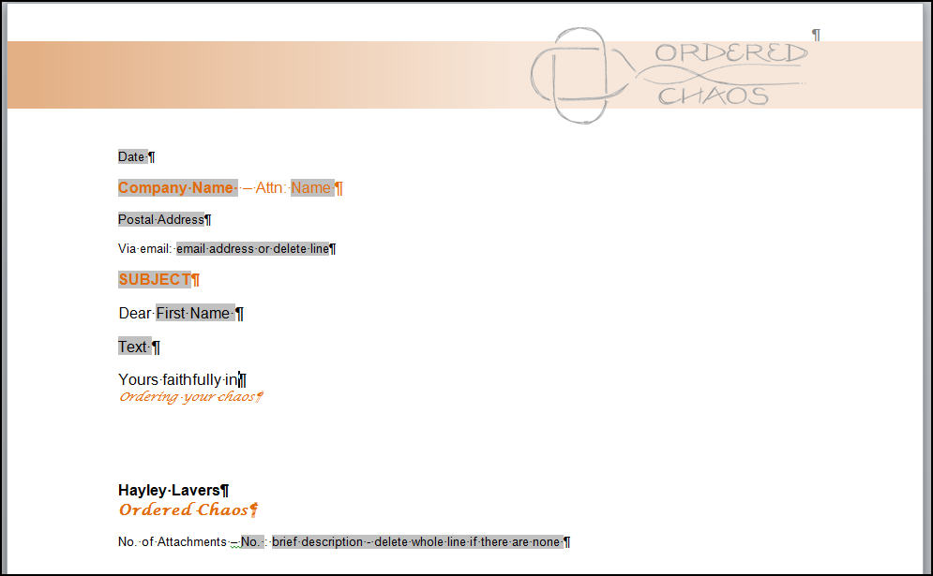

Other template customisation
Other customisation within templates can include creation of auto text, specialised macros and customised toolbars.

Auto Text
Auto text allows for insertion of pre-existing data. This is a huge time saver if you are inserting data again and again. Other uses for auto text include: company tables, logos, headers, footers, address details and much more. These can be setup with abbreviations or shortened text to allow for ease of insertion.

Macros
Macros are the big brother of Auto text (as above), however, they allow for a lot more functionality and customisation. Examples include inserting company headers and footers, inserting landscape pages within a normal portrait document, assigning auto text to buttons in toolbars, applying company colours etc.

Customised Toolbars
The final stage of customisation is to setup your own company toolbar within Word to bring together all the other steps detailed above. Have your own styles, headings, company colours, tables and other features attached to buttons in your own custom toolbar.
Below is an example of a simple toolbar setup called ‘Report’ with customised buttons.
